June 2015

Our Ref: Recruitment/P.Eco/MH/FBH

Dear Applicant,

Ecologist – Market Harborough, Leicestershire

Thank you for your interest in the above post based in our growing Leicestershire office. This letter encloses the following:

- Information about the post
- Application form

If you are interested in applying, please would you send the following:

- Completed application form
- Curriculum vitae

Following review of the applications, a short list of candidates will be contacted for interview. At that stage we will also ask to see some examples of your written reports.

If you would like to talk more informally, please do not hesitate to contact me (DD: 01925 844041).

I look forward to hearing from you. Please submit applications by post, or by email to recruitment@tep.uk.com. The closing date is Tuesday 30th June at 17:00.

Yours sincerely

Francis Hesketh

Francis Hesketh
Ecology Director
TEP

Ecologist (Market Harborough)

The Opportunity
TEP is looking for an ecologist to carry out a variety of ecological survey projects in the Midlands and the South East of England. You will be based in our growing Leicestershire office working alongside archaeologists, arboriculturalists and landscape managers. You would be part of the wider TEP Ecology team comprising 30 ecologists across all the offices. We think this opportunity would appeal to someone who has recently graduated or has one or two years’ experience and is keen to develop their career in an independent environmental consultancy.
About TEP
TEP is an award-winning multi-disciplinary environmental consultancy employing ecologists, landscape architects and urban designers, landscape managers, environmental planners, archaeologists, arboriculturalists and other professionals working on a wide-ranging portfolio. TEP is run by 3 Directors and employs around 130 professional and technical staff. Our head office is in Warrington, with offices in London, Market Harborough, Gateshead and Cornwall. We are passionate about creating quality places for the benefit of people, nature and business.
Our diverse client base includes Homes and Communities Agency, National Grid, many Local Authorities, National Trust, Forestry Commission, United Utilities, renewable energy providers and house builders. Our website www.tep.uk.com shows the breadth of our work.
We place a high value on survey skills, especially botanical and habitat identification, which underpins all ecological assessment.
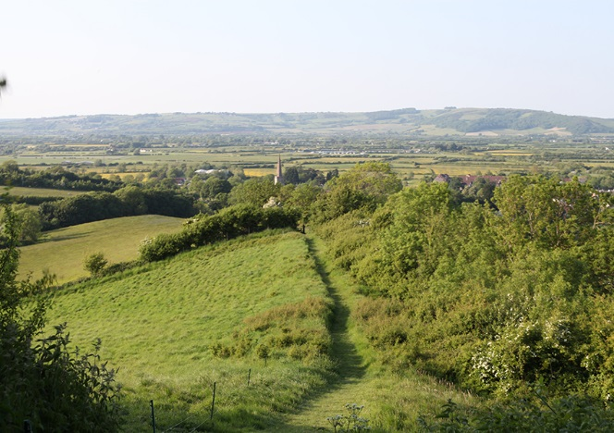
One recent major commission has been ecological assessment and mitigation design for a proposed underground cable in the Mendips. We surveyed all the hedges in detail, identifying constraints on cable routing caused by trees and hedges of value. We then carried out bat surveys and devised a mitigation strategy to ensure that bat flyways are maintained during construction and replacement hedges are sufficiently species-rich to maintain long-term biodiversity value.
The Mendip Hills landscape
The Role and Requirements
We are seeking to appoint an Ecologist with field survey and writing skills.
The position will be based in our Leicestershire office. Most work will be in the Midlands and South East England, but the position may require travel to projects across England, Wales and possibly Scotland. Occasional travel to other TEP offices will also be required. The successful candidate must be able to demonstrate:
- attention to detail and accuracy,
- the ability to work with professionals from other environmental and construction disciplines in order to achieve project objectives.
You will have experience of carrying out, mapping and writing up field survey reports. You will have experience of either (or both of) phase 1 habitat surveys or protected species surveys. The experience may have been gained in a previous consultancy role, or during your academic career.
You will be a member of TEP’s national ecology team and you will work alongside other environmental professionals. Many of our projects require close working with clients to help them through the planning and licensing processes. Experience of working with and advising clients through these processes is desirable.
On a day-to-day basis you will report to a principal ecologist in our Market Harborough office and to our Market Harborough office manager, who is a heritage expert.
We anticipate the post will be mainly of interest to ecologists who have recently graduated, perhaps in 2015, or perhaps in the past 2 years.
Person Specification
Essential:

- Degree in relevant ecology discipline
- (Eligibility for) Graduate Membership of CIEEM
- Strong written communication skills
- Experience of phase 1 habitat survey and/or protected species surveys
- Have assisted in survey or development under a protected species licence (e.g. assistant or accredited agent)
- Competency in the core MS Office applications (Word, Excel and Powerpoint).
- Self-motivated
- Ability to work to deadlines and prioritise competing requirements
- Attention to detail
- Able to work well alone and also as part of a team
- Valid UK Driving Licence

Desirable:

- Botanical skills to FISC Level 3
- Holding a survey or development licence for protected species
- Competency in GIS (preferably ARC)
- Demonstrable experience in writing Ecological Impact Assessments
- Knowledge of the planning process

Equal Opportunities
TEP is an equal opportunities employer and is positive about disabled people. We will guarantee an interview for all disabled candidates meeting the eligibility criteria.

To Apply
Please send your completed application form and CV to recruitment@tep.uk.com.

Closing Date
Closing date for receipt of applications is 5pm on 30th June 2015.

1. Personal Details

Name
Address for correspondence
(inc postcode)

Telephone Number

Email address
National Insurance No.

2. The Post

Post applied for: | Ecologist (Market Harborough)
How did you hear about the post?
In 300 words, tell us about your career to date, your skills and the special attributes you can bring to TEP.
You can provide your answer here, or use a separate sheet. Don’t worry if the text spills over into a separate page.

3. Education and Referees – either fill in details below or refer to your CV (we will verify the authenticity of any qualifications stated on this form)
College or University attended  (State Dates) | Degree, diplomas etc. obtained  (State grades)

Please give details of membership of any professional institutions or societies (and membership number, if known) relevant to the position applied for
Please provide a name and contact details for two referees who can comment on your professional skills and work experience. One should normally be your present or most recent employer.  We will not contact your referees without your permission | Referee 1 | Referee 2

4. Present or Last Employment
Please provide the name, address & telephone number of Company; and a contact name – we will only contact your employer with your permission |  |  |  | Position held | Reason for leaving or wishing to leave | Current/ Last Salary and pension/benefits package
Contact name

Tel:

Email:
Dates employed: | From  Month/  Year |  | To  Month/  Year

5. Previous Employment – if present or last employment was under 3 years please provide employment details to cover this period. If unemployed, please state period of unemployment.
Name and address of Company | Dates employed |  | Position held |  | Reason for leaving
 | From  Month/  Year | To  Month/  Year

6. Other Information

Do you hold a full valid UK driving licence, with 8 or fewer penalty points? | Yes |  | No |  | Comment:
Are you eligible to work in the UK? (1) | Yes |  | No |  | Comment:
Have you undergone a DBS check (Basic Disclosure) in the last 12 months? (2) | Yes |  | No
If Yes, please give date:

Have you undergone a screening test for Drugs & Alcohol in the last 12 months? (2) | Yes |  | No
If Yes, please give date:

- We are only able to accept your application if you are already eligible to work in the UK and can provide evidence to support this.
- Due to client requirements, if successful in your application you will be required to complete a DBS (Basic Disclosure) check and undertake a drugs & alcohol screening test as a condition of employment. If you have this information already, you will need to provide copies of the results to be held in your personnel file.

7. Equal Opportunities – TEP is an Investor in People (Gold). We operate an Equal Opportunities Policy and seek to ensure opportunities for everyone to work safely and maximise their abilities.

Do you consider yourself to have a disability or long-term health condition? | Yes |  | No
Could we make any special provisions to assist during interview or in your work if successful? | Yes |  | No |  | Details:

I confirm that the information I have provided is true and complete to the best of my knowledge.

SIGNED:

NAME:

DATE:

Please send the completed form together with a recent copy of your CV marked ‘Private & Confidential – to Mags Chriscoli, TEP, Genesis Centre, Birchwood Science Park, Warrington, Cheshire, WA3 7BH or email a copy of the completed form to recruitment@tep.uk.com

