TEP – Seasonal Survey Opportunities

TEP is a multi-disciplinary environmental practice which includes a team of more than 30 in-house ecologists. Our work ranges from scoping and survey through to impact assessment, mitigation design, protected species licencing and long-term management.

To cope with the seasonal survey demands, TEP is seeking a group of surveyors to help with our 2018 survey work. This includes newt surveys from March to June and bat surveys from May to September.

The majority of opportunities will be working on projects managed by ecologists based in the North West (Warrington) office, but there may also be opportunities to work on projects in the other TEP offices (Gateshead, Market Harborough, London and Cornwall).

TEP is looking for surveyors with a range of backgrounds from recent graduates through to experienced and licensed ecologists. Training and on the job support will be provided to ensure all surveyors are working to TEP and industry standards. Work is paid at an hourly rate and approved expenses reimbursed. Fixed term contracts may be also be available.

Travel at times of day and to locations where public transport is unavailable means a valid UK driving licence and access to a car is vital for the role. The work may necessitate travel throughout the UK and overnight stays. The following paragraphs provide further information on likely survey work.

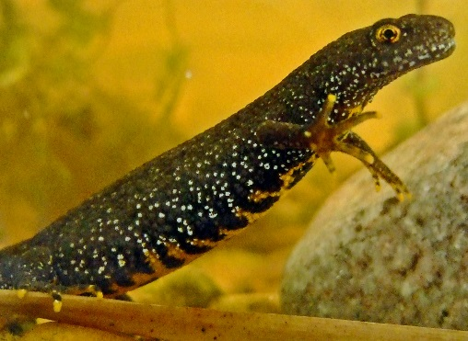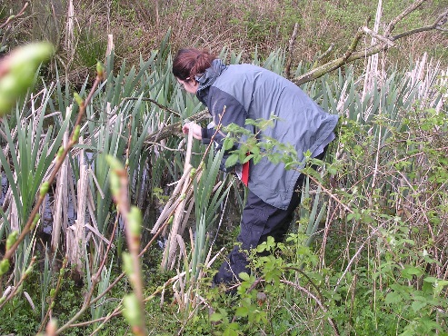

Newt Surveys
Newt surveys comprise work at night followed by an early morning visit and include setting and collecting traps in ponds. Surveys can require substantial walking and usually involve carrying heavy or bulky equipment.
Newt Mitigation
Daytime assistance is commonly required for our amphibian mitigation schemes, where a daily presence (including weekends) is required, to inspect traps and translocate amphibians.

Bat Surveys
Our bat work includes walking transects through a wide range of habitats using bat detectors to identify and record different species and surveys to record bats emerging from roosts in buildings and trees. This work is undertaken at dusk, at dawn or from dusk to dawn.

Health and Safety
Field assistants are required where lone working is not appropriate. This includes working near water (otter and water vole surveys), working at height (bat inspections) and working in very remote locations.
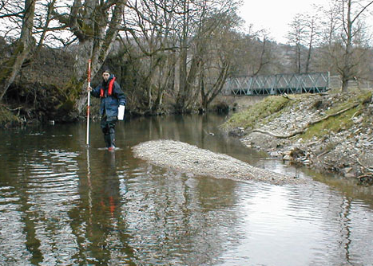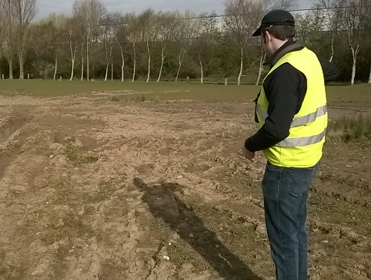

Selection Day
The Selection Day will be held on Friday 2nd February 2018 at the Warrington office. Any interested candidates must complete the application form and email it along with a CV to recruitment@tep.uk.com by noon on Monday 22nd January. Successful candidates will receive an email invite to the Selection Day by Friday 26th January.

Section A: Personal details

Name:

Address:

Telephone:
Mobile:
Email:
Do you have a current driver’s licence? |  | Y/N | If yes, do you have transport? (you will need to obtain business insurance cover) | Y/N
Are you available to attend the Open Day on Friday 2nd February 2018?  Y/N |  |  | If successful would you be available to attend the training day on Wednesday 7th March 2018?  Y/N

Section B: Qualifications and experience

Qualifications:
Degree, postgraduate etc
Training:
Courses, workshops, etc

Professional memberships:
CIEEM, IEMA etc

Experience & skills:
Tick if you have had working experience in any of the following:
Amphibians | ID |  | pond survey/eDNA |  |  | pitfall
Provide further details (if applicable) e.g. would you class yourself as beginner / intermediate / experienced? Have you observed, worked under supervision or worked independently?

Reptiles | ID |  | survey |  |  | translocation
Provide further details (if applicable) e.g. would you class yourself as beginner / intermediate / experienced? Have you observed, worked under supervision or worked independently?

Water voles | ID |  | survey |  |  | translocation
Provide further details (if applicable) e.g. would you class yourself as beginner / intermediate / experienced? Have you observed, worked under supervision or worked independently?

Badgers | ID |  | survey |  |  | sett creation
Provide further details (if applicable) e.g. would you class yourself as beginner / intermediate / experienced? Have you observed, worked under supervision or worked independently?

Bats | ID |  | survey |  |  | sonogram analysis
Provide further details (if applicable) e.g. would you class yourself as beginner / intermediate / experienced? Have you observed, worked under supervision or worked independently?

Small mammals | ID |  | survey |  |  | translocations
Provide further details (if applicable) e.g. would you class yourself as beginner / intermediate / experienced? Have you observed, worked under supervision or worked independently?

Birds | farmland |  | woodland |  |  | coastal
Provide further details (if applicable) e.g. would you class yourself as beginner / intermediate / experienced? Have you observed, worked under supervision or worked independently?

Do you hold survey licences for any of the above? Please list any licences.
Japanese knotweed | ID |  | control
Provide further details (if applicable) e.g. would you class yourself as beginner / intermediate / experienced? Have you observed, worked under supervision or worked independently?

Phase 1 habitat | survey |  | mapping |  |  | extended
Provide further details (if applicable) e.g. would you class yourself as beginner / intermediate / experienced? Have you observed, worked under supervision or worked independently?

NVC | survey |  | mapping |  |  | analysis
Provide further details (if applicable) e.g. would you class yourself as beginner / intermediate / experienced? Have you observed, worked under supervision or worked independently?

Working with contractors
Provide further details (if applicable) e.g. would you class yourself as beginner / intermediate / experienced? Have you observed, worked under supervision or worked independently?

Report writing |  |  |  | Y/N
Provide further details (if applicable):

Use of GIS |  |  |  | Y/N
Provide further details (if applicable):

Knowledge of planning system |  |  |  | Y/N
Provide further details (if applicable):

Knowledge of protected species legislation |  |  |  | Y/N
Provide further details (if applicable):

First Aid Experience |  |  |  | Y/N
Provide further details (if applicable):

Section C: Expectations

Do you want experience in any of the above skills in particular?

What other expectations do you have about working with TEP and the consultancy sector?

Section D: Working Arrangements

The role will require you to work all or some of the following (all in accordance with relevant TEP and project health and safety protocols)

Please indicate whether you are able to do so by ticking either ‘Yes’ or ‘No’:
 | Y | N
Antisocial hours - Nights (sunset to sunrise)
- Weekends
- Bank holidays
Travel long distances
Work away from home for short or prolonged periods
Walk long distances each day, sometimes crossing rough terrain, fences etc
Work in adverse weather conditions
Transport and carry bulky / heavy / wet equipment
Work unaccompanied
Work in isolated areas
Using ladders
Work in as well as near water

Are you currently employed? | Y/N | Full time |  | Part time
If yes, can you work any nights or mornings |  | Nights | Y/N | Mornings | Y/N
Would you leave your current employment for full time contract work with TEP? |  |  |  |  | Y/N
What notice period would be required from your current employer?

Section E: Further information (required)

Are you able to provide documentation to confirm that you have the right to work in the UK? Please be aware that we are only considering applications from individuals who already have the right to work in the UK.

Section F: Further information (optional)

If you have answered ‘no’ to any of the working conditions in Section D, you can use this space to provide details of any constraints / commitments you have which may restrict your working if you wish:

Do you consider yourself to have a disability or long-term health condition?

If yes, is there anything about your condition that may preclude you from working in any of the conditions identified in Section D?

Could we make any special provisions to assist you during your work?

Signed (electronic signature is acceptable):

Print Name:

Date:

Data Protection

When you register for the TEP Ecology Selection Day you accept the statement below:

TEP will use the information given in your application for, recruitment and selection, personnel management and for employment purposes in respect of successful candidates. Access to sensitive personal data is strictly controlled and confined to staff with responsibilities in these areas. If successfully appointed TEP’s Data Protection Policy will apply as relevant to TEP staff or sub-consultants

